Tiverton High School Flood Alleviation Works
A Report by Keith Lewis, former School premises manager, Devon County Council, 1997 – 2014.
Background.
The school is located off Bolham Road and adjacent to the river Exe to the north of the town. The school has expanded on many occasions to accommodate more pupils, including a move to merge the former grammar school which was located in the town centre with the former secondary modern secondary school in the 1970s. In addition, Mid Devon College (now Petroc College) was also relocated to the site to improve post 16 provision for the area.
The flooding problem.
The school site is flat and traditionally flooded when the river Exe was in full flood, exasperated by the bend in the river. The Environment Agency (its predecessor) required the County Council to build flood defences to protect the existing and additional buildings being developed on the site, but was also concerned about the loss of flood capacity at the school site. Eventually an earth bank was built from the new A361 highway to the north and west of the site to the required level, but not to the satisfaction of the Environment Agency. A lack of money contributed to a lack of action in the latter part of the 20th century.
The Final Solution.
At the start of the 21st century there was a need for more school places/buildings as well as expansion of the college. New flood modelling by the Environment Agency required the boundary bank to be increased in height, but was still concerned about the loss of flood capacity on the school site.
The solution to the loss of flood capacity was to make an arrangement with the owner of the adjoining land between the river and the school flood bank to reduce the level of the field by about 0.5m to provide compensatory flooding capacity. The works were completed between 2000 and 2010.
The Google map extract below shows the site and works.
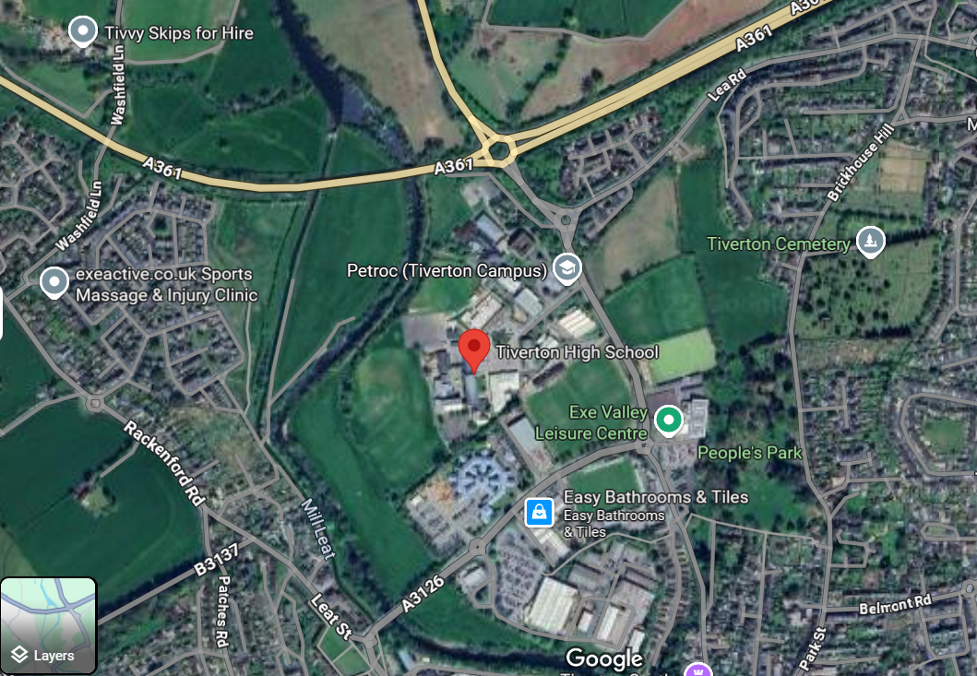
June 2025. For Exeter Civic Society

