
Exeter
Established 1961
Registered Charity No: 286932
Civic Society

Exeter Civil Society – Heritage Harbour Festival: Photo Competition
How well do you know Exeter? The answers.
Thank you so much for taking part in our competition. We hope you had a bit of fun while doing it. Anyway it was good to meet you at the Heritage Harbour Festival.
In the meantime, we had a look through all of the answers and got three winners. Unfortunately, you did not win this time. But you might want to get to know a bit more about the depicted locations here in Exeter and what our Society’s link with them is. We will provide you with a few notes on each photo, and a link to more material on our webpage.
If you think you are interested in joining us, please follow this link: https://exetercivicsociety.org.uk/about-us/join-us/ . The annual fee is only £15 and you can visit a talk on the third Saturday every month, go on our walks on the first Wednesday each month or support our various working groups. We hope to be able to welcome you soon.
Kind regards,
Gert Vonhoff, Chair Strategic Planning & Highways and Festival Coordinator

High time to reveal it all. We hope we will catch your interest with our
ANSWERS:
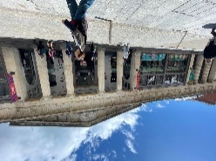
Higher Market, Queens Street: this is very much the reason why Exeter Civic Society formed in 1961-2: This marvellous building was going to be demolished and with all the other things already lost during the post war reconstruction, our founding generation said ‘Enough!’. Their campaigning saved the building. Read more here https://exetercivicsociety.org.uk/about-us/our-history/

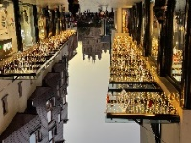
Views from Princesshay onto the Cathedral, Princesshay: Our current president, the Exeter historian Hazel Harvey, made strong points that there should be Cathedral Views when the new Princesshay was planned and constructed. So next time you enjoy this view, think of Exeter Civic Society and what we are doing.

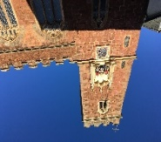
Matthew the Miller Clock, on St Mary’s Steps Church, West Street. Oh yes, you may think. Why did I not remember the name of this little church? I know it well, seen it a lot of times. Well, there are so many of these all over the city centre and luckily despite dwindling congregations, we still have them. This one is special because of its clock and its moving spectacle. To learn more about this and our involvement here, please read https://exetercivicsociety.org.uk/about-us/exeter-history/the-matthew-the-miller-clock/
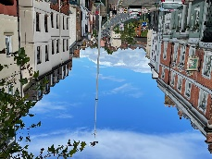
Wyvern Weathervane, Iron Bridge/Lower North Street. This bird on a long pole has become our Society’s logo. It was a weathervane on the former North Gate. The original you can still see in the RAMM. We paid for its conservation and the replica has become our logo. Want to know more about this mysterious creature between bird and dragon, then visit https://exetercivicsociety.org.uk/about-us/exeter-history/the-wyvern-weathervane/
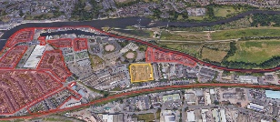
Brownfield Site to be developed, Water Lane area. This is one of our more recent projects. We asked Exeter City Council many times to develop a masterplan for this area, as it is one of the largest inner-city ones which will see development over the next decade. In the end Exeter Civic Society teamed up with local neighbourhood groups, clubs and local councillors and wrote the ‘Prospectus’, which sees itself as a stepping stone towards a masterplan. We have established good working relations with the main developer of this large site and have been reporting back on several stages of their plans. If you are interested in more about this, please visit https://exetercivicsociety.org.uk/concerns/wider-water-lane-area-redevelopment/
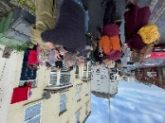
A recently unveiled Blue Plaque: Georg Gissing, 25 Heavitree Road. Our Blue Plaque Team has been researching and setting up these reminders of our local history all over the city for the last 60 years, financed mainly from our membership fees. It is always a little social highlight in our calendar when a new one can be revealed. The one for the late C19 author Georg Gissing who lived for some years in Exeter had the Gissing Society involved as well and saw family members from the U.S. joining in. We also teamed up with the Devon and Exeter Institution for a paper on the author the evening before the unveiling. https://exetercivicsociety.org.uk/plaques/george-gissing/ , https://exetercivicsociety.org.uk/events/blue-plaque-unveiling-george-gissing-20231208/, https://exetercivicsociety.org.uk/prof-richard-dennis-unveiled-george-gissing-plaque/

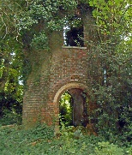
Larkbeare Belvedere, Larkbeare House Garden, off Holloway Street/Topsham Road, behind Colleton Hill. We thought with all your good knowledge about Exeter, we would need a decider and that is where this location came in. Only very few people in Exeter will know where this is. The photo shows the structure in a slightly better state than the photo we were able to take in February this year. It is the remains of a C18 tower in the grounds of Larkbeare House, sometimes referred to as a Belvedere other times as a Garden House. We got aware of it during our Tree Mapping exercise this year, when we saw house and grounds under danger of potential redevelopment and our ‘Tree Preservation Task Force’ got active. Devon County Council is going to sell this property, as they no longer need the rooms. As we found out, neither house nor gardens are listed. So we teamed up with Devon Gardens Trust and convinced Historic England that it would be high time to look into listing these structures. If you want to see how our campaign this spring developed, follow the details up under https://exetercivicsociety.org.uk/7-days-to-save-larkbeare-house/

Joining us and supporting our work is easy, please follow this link on our website: https://exetercivicsociety.org.uk/about-us/join-us/ .

